**CAPTAIN Moderation Data Analysis Report, 02-10-2022**

For each analysis, out of total 3,600 unique CAPTAIN participants, we filtered participants who were missing any of the variable pairs used. For example, if the analysis included variables, ICS Setting total, amount of ASD experience, and EBP primary outcome score, only participants who were not missing any of those variables were used. Then, those who were missing SELPA or district were excluded, since we used SELPA and district variables as random effects in our models. This was the process for creating the final dataset for each analysis.

**ICS (Total and Each Subscales) – ASD Experience – EBP Outcome Models**

Out of the 1,084 participants, 884 (81.5%) were females and 120 (11.1%) were males. The participants were from 117 different SELPAs and 333 different districts. The number of participants from each SELPA ranged from 1 to 53 participants, and it was 1 to 50 from each district. Almost all of them were Direct Support Professionals (99.5%). Seventy one percent identified themselves as Caucasians, followed by 4.4% as Asians and 1.3% as African American, with 16.9% from mixed/other/refused categories. About half of them were younger than the age of 45.

The range of ICS total was 0 to 100, with an overall mean of 40.3 (SD=22), and subscale means ranged from 2.3 (SD=3.0) to 6.4 (SD=3.3). As for EBP outcome, the range was 0 to 4 with the mean 2.54 (SD=0.86). ASD experience was initially categorical, with values ranging from “Little to no experience” to “Extensive hands-on experience”, but was transformed into a 0-3 numeric scale representing increasing experience with ASD.

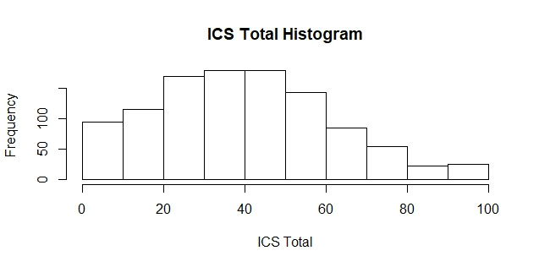Below were histograms of the variables used for the model in this report:

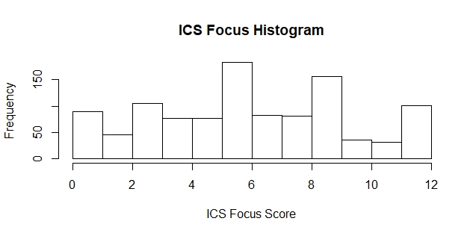The analysis examined EBP outcome as a dependent variable, predicted by ICS total score, and whether the relationship between ICS total score and EBP outcome was moderated by the amount of ASD experience. Multilevel modeling was conducted in R using lme4 package (Bates, Maechler, Bolker, & Walker, 2015) in order to account for the nested nature of the data, where participants are grouped within Districts which, in turn, are grouped within SELPAs. We first examined an unconditional model, with no fixed effects, in order to assess the variances of the random effects of District and SELPA. For simplicity, District and SELPA were modeled as orthogonal random effects. As a result, 3.2% of variance in EBP outcome is accounted for by district, and 1.6% by SELPA. District and SELPA both accounted for very little variance, but were retained in the model as random effects as per the design of the study:

*Model 1: EBP outcome ~ 1 + (1|District) + (1|SELPA)*

Building on this base model, we next added ICS total score as a fixed main effect:

*Model 2: EBP outcome ~ 1 + ICS Total + (1|District) + (1|SELPA)*

Testing between the two models above, using deviance values between -2LogLikelihood scores distributed as a Chi-square, with the degrees of freedom equal to the difference in number of estimated parameters, we found that the main effect of ICS total score on EBP outcome was significant (Chi-square = 50.63, df = 1, p-value < 0.001). This result indicated that the higher ICS total score, the higher EBP outcome score, and the relationship is significant. Specifically, for every 1 point gain in ICS Setting total score, there was a respective increase in EBP Outcome scores of 0.0092 (SE = 0.0011, t = 7.28).

Building on model 2, we next added ASD experience as second main effect:

*Model 2.1: EBP outcome ~ 1 + ICS Total + ASD Exp + (1|District) + (1|SELPA)*

Again, comparing models 2 and 2.1 revealed that ASD experience was also a significant predictor of EBP Outcome scores (Chi-square = 105.78, df = 1, p-value < 0.001). This result indicated that increased experience with ASD was significantly related to EBP Outcome scores, with a gain of 0.33 (SE = 0.032, t = 10.53) in EBP Outcome scores with each 1 point gain in the 4-point scale of ASD experience.

After investigating the main effects, we next examined how ASD experience moderated the relationship between ICS and EBP Use by including an interaction term between ICS and ASD experience in the model. The model fitted is shown below:

*Model 2.2: EBP outcome ~ 1 + ICS Total + ASD Exp + ICS Total * ASD Exp + (1|District) + (1|SELPA)*

Comparing model 2.1 and 2.2, we found that the interaction effect between ICS total and ASD experience was significant (Chi-square = 10.91, df = 1, p-value < 0.001). This result indicated that as ASD experience decreased, the relationship between ICS and EBP Use became more robust (SE=0.0014, t = -3.31). This interaction is illustrated in Figure 1 below. For individuals with no experience with ASD, EBP Outcome scores increased approximately 1 as ICS total increased from 25 to 75, whereas for those with a lot of experience with ASD, EBP Outcome scores only increased approximately 0.25 with increasing ICS total.

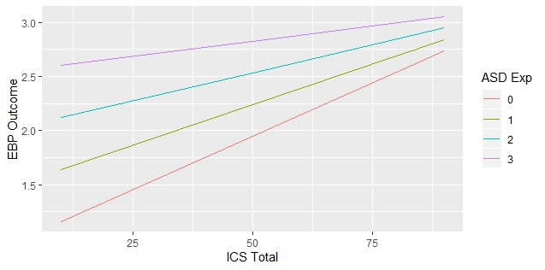Figure 1: oderation effect of ASD experience on ICS as a predictor of EBP Outcome

Then, we wanted to investigate which subscales show significant moderation effect. Therefore, we fitted the model replacing ICS total with each subscale score. The models are below:

*Model 3.1: EBP outcome ~ 1 + ICS Focus + ASD Exp + (1|District) + (1|SELPA)*

*Model 3.2: EBP outcome ~ 1 + ICS Focus + ASD Exp + ICS Focus * ASD Exp + (1|District) + (1|SELPA)*

*Model 4.1: EBP outcome ~ 1 + ICS Educational Support + ASD Exp + (1|District) + (1|SELPA)*

*Model 4.2: EBP outcome ~ 1 + ICS Educational Support + ASD Exp + ICS Educational Support * ASD Exp + (1|District) + (1|SELPA)*

*Model 5.1: EBP outcome ~ 1 + ICS Recognition + ASD Exp + (1|District) + (1|SELPA)*

*Model 5.2: EBP outcome ~ 1 + ICS Recognition + ASD Exp + ICS Recognition * ASD Exp + (1|District) + (1|SELPA)*

*Model 6.1: EBP outcome ~ 1 + ICS Rewards + ASD Exp + (1|District) + (1|SELPA)*

*Model 6.2: EBP outcome ~ 1 + ICS Total + ASD Exp + ICS Rewards * ASD Exp (1|District) + (1|SELPA)*

*Model 7.1: EBP outcome ~ 1 + ICS Selection + ASD Exp + (1|District) + (1|SELPA)*

*Model 7.2: EBP outcome ~ 1 + ICS Selection + ASD Exp + ICS Selection * ASD Exp + (1|District) + (1|SELPA)*

*Model 8.1: EBP outcome ~ 1 + ICS Selection for Openness + ASD Exp + (1|District) + (1|SELPA)*

*Model 8.2: EBP outcome ~ 1 + ICS Selection for Openness + ASD Exp + ICS Selection for Openness * ASD Exp + (1|District) + (1|SELPA)*

*Model 9.1: EBP outcome ~ 1 + ICS Existing Support + ASD Exp + (1|District) + (1|SELPA)*

*Model 9.2: EBP outcome ~ 1 + ICS Existing Support + ASD Exp + ICS Existing Support * ASD Exp + (1|District) + (1|SELPA)*

*Model 10.1: EBP outcome ~ 1 + ICS Use of Data + ASD Exp + (1|District) + (1|SELPA)*

*Model 10.2: EBP outcome ~ 1 + ICS Use of Data + ASD Exp + ICS Use of Data * ASD Exp + (1|District) + (1|SELPA)*

Comparing each model between with and without interaction term, we found that ASD experience had significant moderation effects (p-values < 0.05) between EBP Outcome and following ICS subscales: Focus, Educational Support, Selection, Selection for Openness, Existing Support, and Use of Data

Expanding our analyses, we set up more models by replacing ASD experience variable with three other possible moderators: poverty rate for each SELPA and years of CAPTAIN participation. Through this, we wanted to see if these variables are significant predictors of EBP outcome, as well as significantly moderate the relationship between ICS score and EBP outcome. Performance score was a possible moderator as well, but since there were only 16 participants who had ICS total, performance score, and EBP outcome, we excluded the variable from the analysis.

**ICS Total – Poverty Rate – EBP Outcome**

Out of the 1,035 participants, 846 (81.7%) were females and 118 (11.4%) were males. The participants were from 114 different SELPAs and 291 different districts. The number of participants from each SELPA ranged from 1 to 53 participants, and 1 to 51 from each district. Just as previous dataset, most of them were Direct Support Professionals (96.1%), with majority of them as Caucasian. About half of them (52.9%) were younger than the age of 45. Below is the histogram for poverty rate by district:

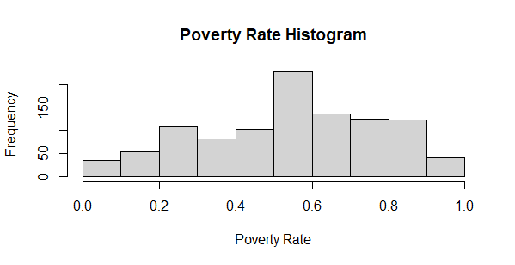

The models were built as below to compare whether the moderation effect was significant:

*Model 11.1: EBP outcome ~ 1 + ICS Total + Poverty Rate by District + (1|District) + (1|SELPA)*

*Model 11.2: EBP outcome ~ 1 + ICS Total + Poverty Rate by District + ICS Total * Poverty Percentage + (1|District) + (1|SELPA)*

The result turned out that poverty rate by District level did not have a significant moderation effect to the relationship between ICS total and EBP outcome (Chi-square = 0.35, df = 1, p-value = 0.56). The result showed there may be possible positive correlation between poverty rate and EBP outcome. (t ~~ 1, SE = 0.28).

**ICS Total – Cadre Training – EBP Outcome**

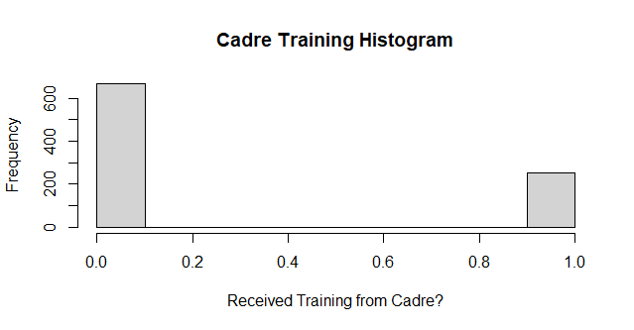There were 922 participants, who had non-missing ICS total, cadre training received or not, and EBP outcome data. Out of those, 761 (82.5%) were females and 99 (10.7%) were males. The participants were from 115 different SELPAs and 307 different districts. The number of participants from each SELPA ranged from 1 to 44 participants, while 1 to 43 from each district. Just as previous dataset, most of them were Direct Support Professionals (96%), with majority of them (71.7%) as Caucasian. 52.2% of them were younger than the age of 45. Below was the histogram for whether the participant received cadre training or not (with 0 as no, and 1 as yes):

Similar to the previous procedures, the models were built and are shown below:

*Model 12.1: EBP outcome ~ 1 + ICS Total + Cadre Training + (1|District) + (1|SELPA)*

*Model 12.2: EBP outcome ~ 1 + ICS Total + Cadre Training + ICS Total * CAPTAIN Participation + (1|District) + (1|SELPA)*

Same the previous result, it turned out that the number of years of CAPTAIN participation did not significantly moderate the relationship between ICS total and EBP outcome (Chi-square = 1.74, df = 1, p-value = 0.19). The result showed there may be possible positive relationship between cadre training and EBP outcome. (t = 1.89, SE = 0.062).

**EBP Resources (by district) – Poverty Rate (by district) – CDE Outcome (by district)**

This dataset was aggregated by each district. It consisted of 62 SELPA’s across 95 districts. CDE data were collected from 2015 to 2019, and we chose to use year 2018-2019 data. Below are histograms for variables used for the models:

The models used were listed below. Since the data was consolidated by district, the models do not contain district random effect anymore.

*Model 13: CDE Math ~ 1 + EBP Resources Total + (1|SELPA)*

*Model 13.1: CDE Math ~ 1 + EBP Resources Total + + Poverty Rate + (1|SELPA)*

*Model 13.2: CDE Math ~ 1 + EBP Resources Total + Poverty Rate + EBP Resources Total * Poverty Rate + (1|SELPA)*

*Model 14: CDE ELA ~ 1 + EBP Resources Total + (1|SELPA)*

*Model 14.1: CDE ELA ~ 1 + EBP Resources Total + + Poverty Rate + (1|SELPA)*

*Model 14.2: CDE ELA ~ 1 + EBP Resources Total + Poverty Rate + EBP Resources Total * Poverty Rate + (1|SELPA)*

*Model 15: CDE ELA ~ 1 + EBP Resources Total + (1|SELPA)*

*Model 15.1: CDE ELA ~ 1 + EBP Resources Total + + Poverty Rate + (1|SELPA)*

*Model 15.2: CDE ELA ~ 1 + EBP Resources Total + Poverty Rate + EBP Resources Total * Poverty Rate + (1|SELPA)*

*Model 16: CDE RC80 ~ 1 + EBP Resources Total + (1|SELPA)*

*Model 16.1: CDE RC80 ~ 1 + EBP Resources Total + + Poverty Rate + (1|SELPA)*

*Model 16.2: CDE RC80 ~ 1 + EBP Resources Total + Poverty Rate + EBP Resources Total* Poverty Rate + (1|SELPA)*

*Model 17: CDE Sepschool ~ 1 + EBP Resources Total + (1|SELPA)*

*Model 17.1: CDE Sepschool ~ 1 + EBP Resources Total + + Poverty Rate + (1|SELPA)*

*Model 17.2: CDE Sepschool ~ 1 + EBP Resources Total + Poverty Rate + EBP Resources Total * Poverty Rate + (1|SELPA)*

*Model 18: CDE Suspension Rate ~ 1 + EBP Resources Total + (1|SELPA)*

*Model 18.1: CDE Suspension Rate ~ 1 + EBP Resources Total + + Poverty Rate + (1|SELPA)*

*Model 18.2: CDE Suspension Rate ~ 1 + EBP Resources Total + Poverty Rate + EBP Resources Total * Poverty Rate + (1|SELPA)*

The definitions of those CDE variables were also listed below:

|  |  |
| --- | --- |
| **Variable** | **Definition** |
| CDE Math | Percentage of students who scored at least Level 3 (Standard Met) in math, with AUT as their disability in the CAASSP Assessment |
| CDE ELA | Percentage of students who scored at least Level 3 (Standard Met) in English, with AUT as their disability in the CAASSP Assessment |
| CDE RC80 | Percentage of students in regular class for greater than 80% of the day, with Autism as their primary disability |
| CDE Sepschool | Percentage of students in separate placements, with Autism as their primary disability |
| CDE Suspension | Percentage of Suspension within the given year |

The only time when the main effect for poverty rate was significant was between the model 17 and 17.1 (Chi-square = 7.44, df = 1, p-value < 0.01). The result showed there was negative relationship between poverty rate and CDE Sepschool (t = -2.75, SE = 0.02).

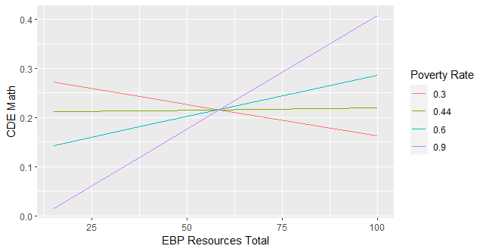Significant moderation effect was only observed in the model 13.2 (Chi-square = 8.3, df = 1, p-value < 0.005). The result indicated that poverty rate moderated positively between EBP resources total score and CDE math outcome (t = 2.98, SE = 0.0036). The relationship between EBP resources and CDE math became positive starting approximately when the poverty rate was 0.44. The plot to show the effect was below:

**Cadre Training – CDE Outcome**

We also investigated the impact of cadre training on CDE outcome. The data consisted of 1,298 participants, where 884 (68.1%) of them and 124 (9.55%) of them were identified themselves as females and males respectively. The participants were from 110 different SELPAs and 332 different districts. The number of participants from each SELPA ranged from 1 to 59 participants, so as each district.

In order to examine whether the relationship between two variables was significant, linear models were built followed by ANOVA test. The models built along with ANOVA results were listed below:

*Model 19: CDE Math ~ 1 + Cadre Training (t = -4.87, p-value < 0.001)*

*Model 20: CDE ELA ~ 1 + Cadre Training (t = -4.78, p-value < 0.001)*

*Model 21: CDE RC80 ~ 1 + Cadre Training (t = -1.74, p-value < 0.1)*

*Model 22: CDE Sepschool ~ 1 + Cadre Training (t = -0.12, p-value > 0.9)*

*Model 23: CDE Suspension ~ 1 + Cadre Training (t = 1.62, p-value > 0.1)*

The results indicated that there are significant negative correlations between Cadre training and CDE Math and ELA.

**EBP Outcome – CDE Outcome**

Lastly, we observed the impact of EBP use outcome on CDE outcome. The data consisted of 1,333 participants, where 980 (73.5%) of them and 138 (10.4%) of them were identified themselves as females and males respectively. The participants were from 109 different SELPAs and 320 different districts. The number of participants from each SELPA ranged from 1 to 64 participants, so as each district.

In order to examine whether the relationship between two variables was significant, linear models were built followed by ANOVA test. The models built along with ANOVA results were listed below:

*Model 24: CDE Math ~ 1 + EBP Outcome (t = -0.93, p-value = 0.35)*

*Model 25: CDE ELA ~ 1 + EBP Outcome (t = -0.96, p-value = 0.34)*

*Model 26: CDE RC80 ~ 1 + EBP Outcome (t = -3.24, p-value < 0.01)*

*Model 27: CDE Sepschool ~ 1 + EBP Outcome (t = -0.52, p-value > 0.6)*

*Model 28: CDE Suspension ~ 1 + EBP Outcome (t = -1.2, p-value = 0.23)*

The results indicated that there are significant negative correlation between EBP outcome and CDE RC80.